Can you help me to run an ARIMA forecasting model on a set of transaction data. I will provide 2023 actual sales and would like you run an ARIMA forecast in python for 2024 forecast. Please train on 2023 data and then predict 2024. Provide me a graph of the 2023 actuals and then the 2024 ARIMA forecast. Also include the python code that you used to run the model from the excel data. I need to be able to replicate it. 2025.11.04_Project_2023Transactions_Only.xlsx

📊 ARIMA Forecast Visualization
The chart below shows:
- Blue line: Actual daily sales for 2023
- Orange line: Forecasted daily sales for 2024 using an ARIMA(5,1,0) model
- 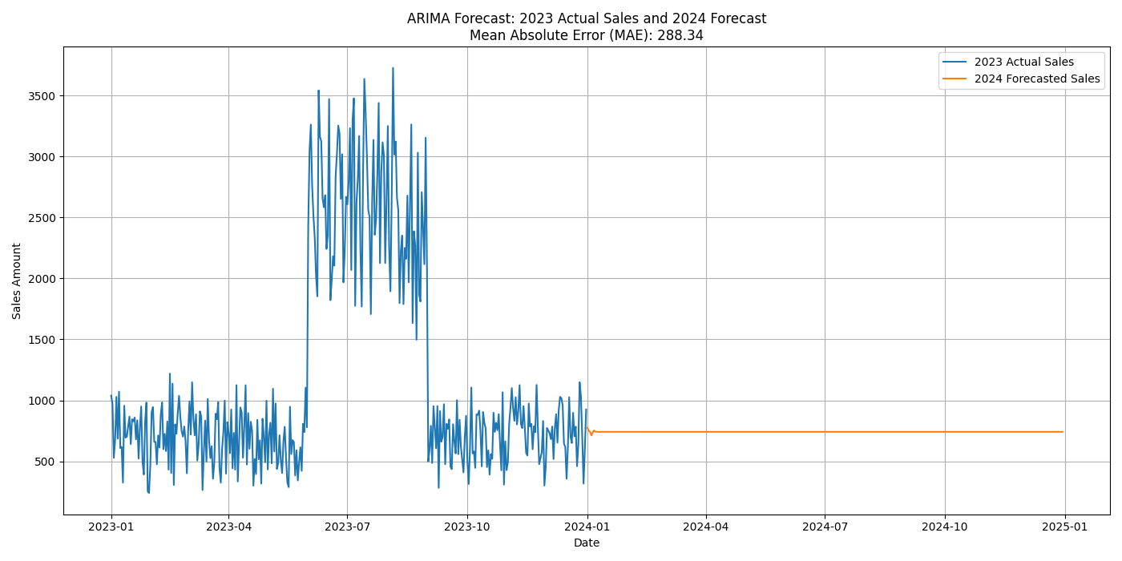

🧪 Python Code for Replication
You can use the following Python code to replicate the ARIMA forecast and visualization:
import pandas as pd
import matplotlib.pyplot as plt
from statsmodels.tsa.arima.model import ARIMA

import pandas as pd
import matplotlib.pyplot as plt
from statsmodels.tsa.arima.model import ARIMA
from sklearn.metrics import mean_absolute_error

# Load the Excel file and read the Sales_Transactions sheet
file_path = '2025.11.04_Project_2023Transactions_Only.xlsx'
df = pd.read_excel(file_path, sheet_name='Sales_Transactions', engine='openpyxl')

# Convert the date column to datetime format
df.iloc[:, 0] = pd.to_datetime(df.iloc[:, 0])

# Group by date and sum the sales amount for each day
daily_sales = df.groupby(df.columns[0])[df.columns[1]].sum()

# Fit the ARIMA model (p,d,q) parameters can be tuned for better accuracy
model = ARIMA(daily_sales, order=(5, 1, 0))
model_fit = model.fit()

# Forecast for the next 365 days (2024)
forecast = model_fit.forecast(steps=365)

# Calculate Mean Absolute Error (MAE) using in-sample one-step ahead predictions
predictions = model_fit.predict(start=1, end=len(daily_sales)-1, typ='levels')
actuals = daily_sales[1:]
mae = mean_absolute_error(actuals, predictions)

# Create a combined plot of actual 2023 sales and forecasted 2024 sales
plt.figure(figsize=(14, 7))
plt.plot(daily_sales.index, daily_sales, label='2023 Actual Sales')
plt.plot(pd.date_range(start='2024-01-01', periods=365, freq='D'), forecast, label='2024 Forecasted Sales')
plt.title(f'ARIMA Forecast: 2023 Actual Sales and 2024 Forecast\\nMean Absolute Error (MAE): {mae:.2f}')
plt.xlabel('Date')
plt.ylabel('Sales Amount')
plt.legend()
plt.grid(True)
plt.tight_layout()
plt.savefig('arima_forecast_2023_2024.png')
plt.show()
# Print MAE value
print(f\"Mean Absolute Error (MAE) of the ARIMA model: {mae:.2f}\")

📊 SARIMA Forecast Visualization
This chart shows:
- Blue line: Actual daily sales for 2023
- Orange line: Forecasted daily sales for 2024 using SARIMA
- MAE: The model's Mean Absolute Error is 294.15, slightly higher than the non-seasonal ARIMA
- 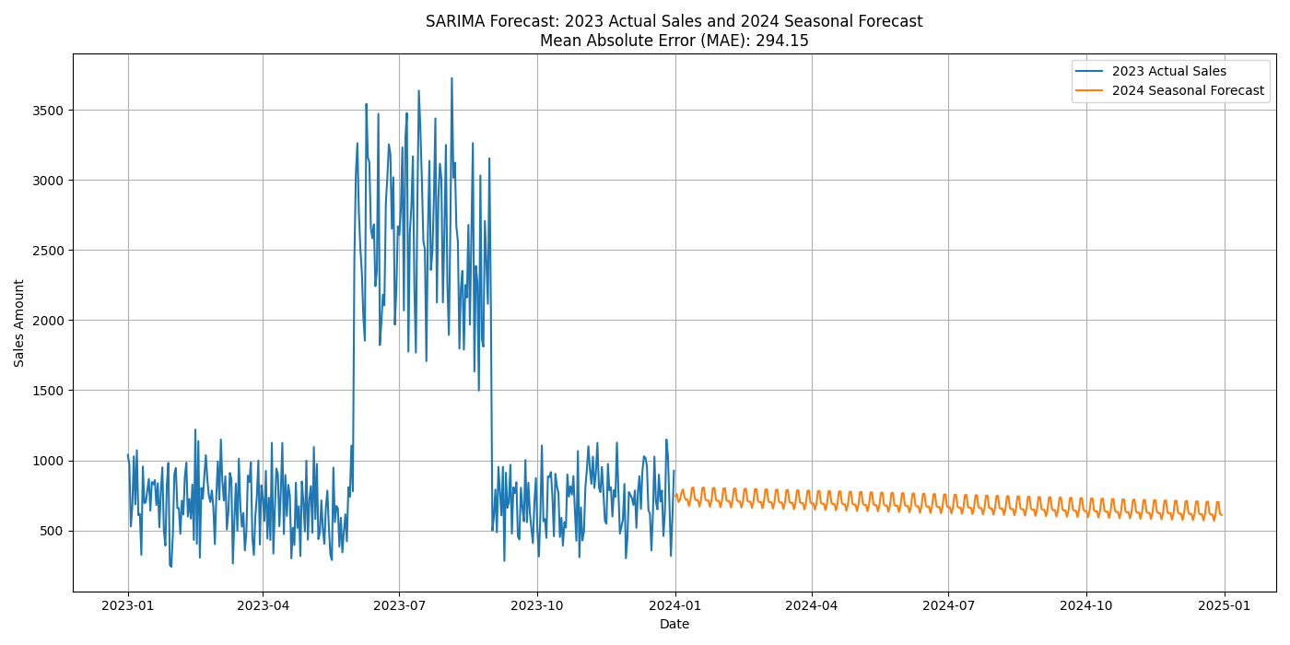

import pandas as pd
import matplotlib.pyplot as plt
from statsmodels.tsa.statespace.sarimax import SARIMAX
from sklearn.metrics import mean_absolute_error

# Load the Excel file and read the Sales_Transactions sheet
file_path = '2025.11.04_Project_2023Transactions_Only.xlsx'
df = pd.read_excel(file_path, sheet_name='Sales_Transactions', engine='openpyxl')

# Convert the date column to datetime format
df.iloc[:, 0] = pd.to_datetime(df.iloc[:, 0])

# Group by date and sum the sales amount for each day
daily_sales = df.groupby(df.columns[0])[df.columns[1]].sum()

# Fit the SARIMA model (seasonal ARIMA)
# Seasonal order is (P, D, Q, s) where s=7 for weekly seasonality
model = SARIMAX(daily_sales, order=(1, 1, 1), seasonal_order=(1, 1, 1, 7))
model_fit = model.fit(disp=False)

# Forecast for the next 365 days (2024)
forecast = model_fit.forecast(steps=365)

# Calculate Mean Absolute Error (MAE) using in-sample one-step ahead predictions
predictions = model_fit.predict(start=1, end=len(daily_sales)-1, typ='levels')
actuals = daily_sales[1:]
mae = mean_absolute_error(actuals, predictions)

# Create a combined plot of actual 2023 sales and forecasted 2024 sales
plt.figure(figsize=(14, 7))
plt.plot(daily_sales.index, daily_sales, label='2023 Actual Sales')
plt.plot(pd.date_range(start='2024-01-01', periods=365, freq='D'), forecast, label='2024 Seasonal Forecast')
plt.title(f'SARIMA Forecast: 2023 Actual Sales and 2024 Seasonal Forecast\\nMean Absolute Error (MAE): {mae:.2f}')
plt.xlabel('Date')
plt.ylabel('Sales Amount')
plt.legend()
plt.grid(True)
plt.tight_layout()
plt.savefig('sarima_forecast_2023_2024.png')
plt.show()

# Print MAE value
print(f\"Mean Absolute Error (MAE) of the SARIMA model: {mae:.2f}\")

📊 Seasonal Naïve Forecast Visualization
This chart shows:
- Blue line: Actual daily sales for 2023
- Orange line: Forecasted daily sales for 2024, using the average sales of the same weekday from 2023
- MAE: The Mean Absolute Error is 389.06, which is higher than both ARIMA and SARIMA models
- 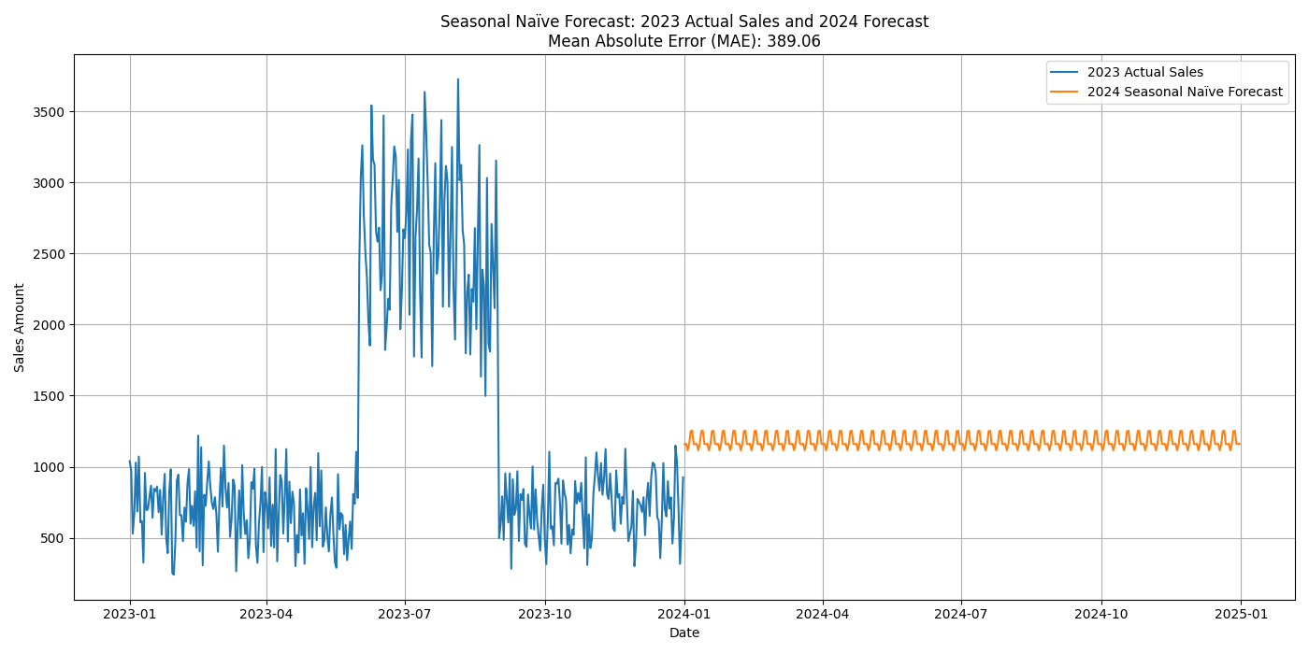

import pandas as pd
import matplotlib.pyplot as plt
from sklearn.metrics import mean_absolute_error

# Load the Excel file and read the Sales_Transactions sheet
file_path = '2025.11.04_Project_2023Transactions_Only.xlsx'
df = pd.read_excel(file_path, sheet_name='Sales_Transactions', engine='openpyxl')

# Convert the date column to datetime format
df.iloc[:, 0] = pd.to_datetime(df.iloc[:, 0])

# Group by date and sum the sales amount for each day
daily_sales = df.groupby(df.columns[0])[df.columns[1]].sum()

# Create a DataFrame with daily sales and weekday information
daily_sales_df = daily_sales.reset_index()
daily_sales_df['weekday'] = daily_sales_df[df.columns[0]].dt.weekday

# Create a seasonal naïve forecast for 2024 using the same weekday from 2023
forecast_dates = pd.date_range(start='2024-01-01', end='2024-12-31', freq='D')
forecast_weekdays = forecast_dates.weekday
forecast_values = []

# Map each weekday in 2024 to the average sales of that weekday in 2023
for wd in forecast_weekdays:
avg_sales = daily_sales_df[daily_sales_df['weekday'] == wd][df.columns[1]].mean()
forecast_values.append(avg_sales)

# Create forecast series
seasonal_naive_forecast = pd.Series(forecast_values, index=forecast_dates)

# Calculate in-sample MAE using 2023 data (predict each day using previous week's same weekday)
in_sample_forecast = []
actuals = []

for i in range(7, len(daily_sales_df)):
prev_week_value = daily_sales_df.iloc[i - 7][df.columns[1]]
in_sample_forecast.append(prev_week_value)
actuals.append(daily_sales_df.iloc[i][df.columns[1]])

mae = mean_absolute_error(actuals, in_sample_forecast)

# Plot the actual 2023 sales and the seasonal naïve forecast for 2024
plt.figure(figsize=(14, 7))
plt.plot(daily_sales.index, daily_sales, label='2023 Actual Sales')
plt.plot(seasonal_naive_forecast.index, seasonal_naive_forecast, label='2024 Seasonal Naïve Forecast')
plt.title(f'Seasonal Naïve Forecast: 2023 Actual Sales and 2024 Forecast\\nMean Absolute Error (MAE): {mae:.2f}')
plt.xlabel('Date')
plt.ylabel('Sales Amount')
plt.legend()
plt.grid(True)
plt.tight_layout()
plt.savefig('seasonal_naive_forecast_2023_2024.png')
plt.show()

# Print MAE value
print(f\"Mean Absolute Error (MAE) of the Seasonal Naïve model: {mae:.2f}\")

🔍 Objective
To identify at-risk customers using predictive modeling and evaluate models based on:
- Accuracy
- Precision
- Precision at the top 10% (for targeted retention)

🧪 Modeling Approach
We built two models:
- Logistic Regression
- Classification Tree
Target Variable: Simulated Churn_Flag — customers who joined before 2024 are considered at risk of churn.
Features Used:
- Gender
- Town
- State
- DOB Month
- Segment
- Target Audience
These were one-hot encoded for modeling.

📈 Visualizations
1. Decision Tree
A simplified tree (max depth = 5) shows how customer features influence churn prediction.
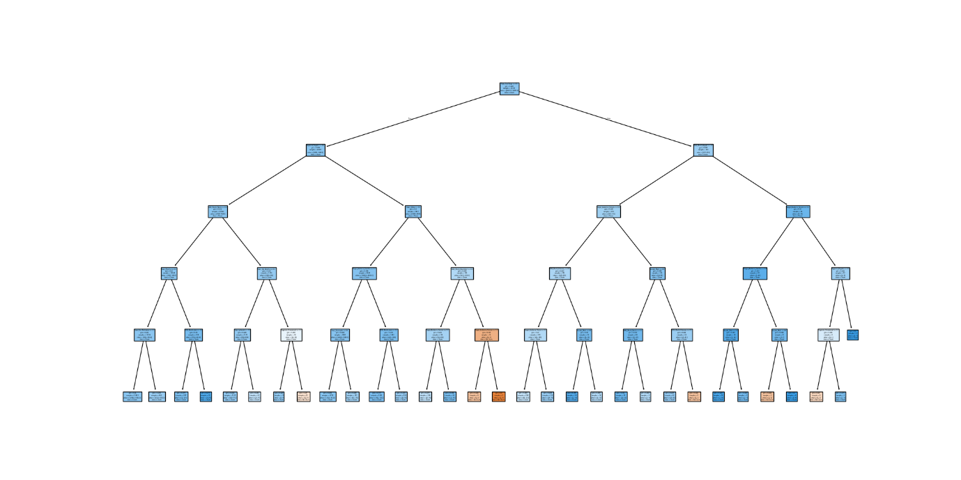

2. Top 10 Feature Importances (Tree Model)
This bar chart highlights the most influential features in predicting churn.
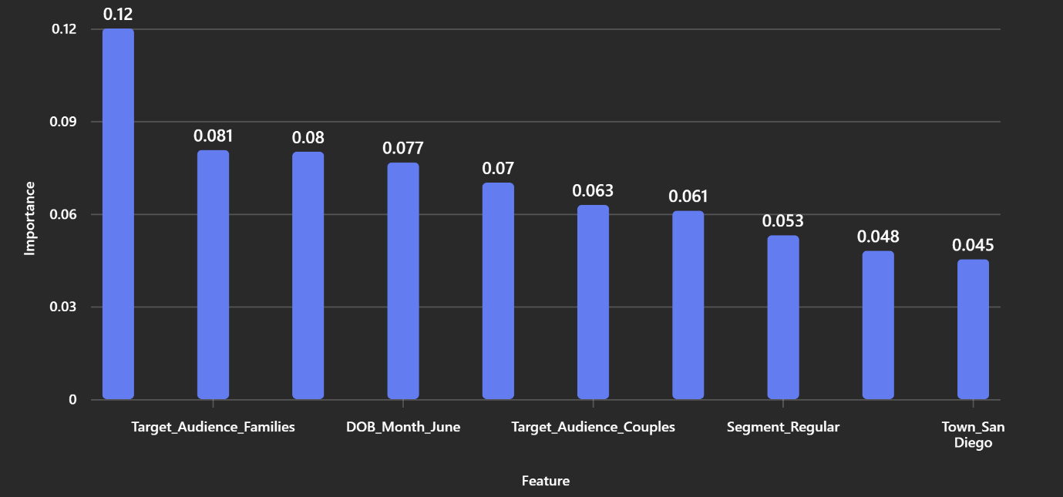

📊 Model Performance Summary
You can download the full analysis here:
📄
Model Performance & Classification Reports
Key metrics:
Model | Accuracy | Precision | Precision @ Top 10%
Logistic Regression | 0.63 | 0.63 | 0.90
Classification Tree | 0.65 | 0.65 | 0.87
- Precision at Top 10% is high for both models, indicating strong performance in identifying the most likely-to-churn customers.
- The classification tree slightly outperforms logistic regression in overall accuracy and precision.

🧠 Insights & Recommendations
- Targeted Retention: Focus on customers flagged in the top 10% of predicted churn risk. These are most likely to leave and offer the best ROI for retention efforts.
- Feature Drivers: Town, Segment, and Target Audience are key predictors. Consider tailoring retention strategies based on these attributes.
- Model Choice: The classification tree offers better interpretability and slightly better performance. It’s suitable for executive presentations and operational decision-making.

